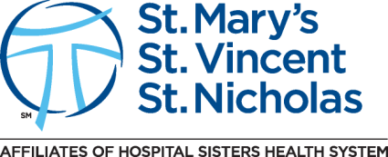

My signature indicates that I have reviewed the contents of the Rapid Regulatory documents, St. Nicholas Hospital Confidentiality policy, Emergency Response Codes, Personal Appearance and I understand and am responsible for the information contained on these orientation documents..

Name _____________________________________ School________ ________________
Printed

Signature______________________________________________ Date_______________

Return this form to the person who provided this orientation packet to you.

